Olzhas Zhakhanger JA363R
Financial Data Analysis, Homework #1
- Dowload publicly available daily stock price data (close prices) for minimum 3 months. Describe the source of data and plot the time series that shows the stock price data. (2 points)
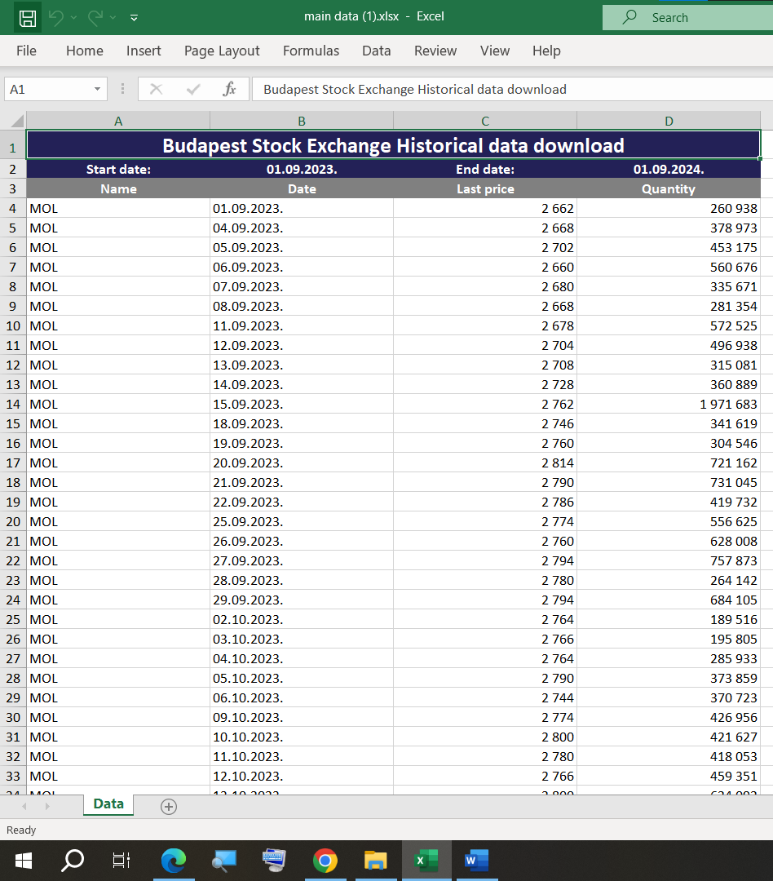
I used the website BSe.hu and downloaded the dataset of MOL company from 2023-01-09 to 2024-12-08. In the analysis, I used the full period. The website bse.hu is for a Hungarian stock market exchange. The Excel file contains the columns Name, Date, Last price, and Quantity. This data is recorded day-by-day, so it is considered as time seris. To illustrate the stock data price, I used y-axis as Date and x-axis as Last Price and made a line chart. This graph perfectly shows how it changed over the period and it Is visible that the smooth evolution of the price over time rather random jumps, which makes it matching for further time-series analusis.

- Calculate the first-order autocorrelation value for the stock price data, and interpret the autocorrelation value (whether the autocorrelation differs significantly from zero at a 5% significance level). (4 points)
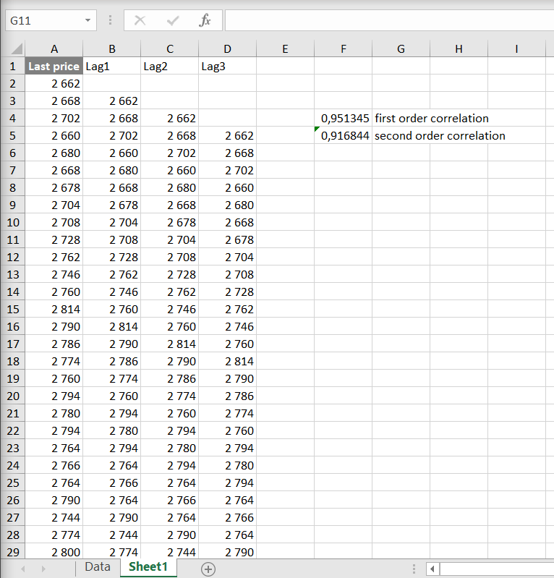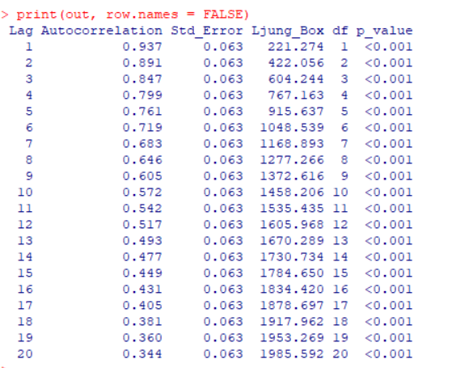
I computed the first-order autocorrelation of the Last price series, as in class. This statistic shows how much today’s price is related to yesterday’s price. The result is 0.9513, which is very close to 1, which means very strongly postitvely dependand from one day to the next.
To check significance at the 5% level, I compared first correlation to the 95% band ±1.96/n^(1/2) [This is under the root]. As our major is Data Science, we learned this mathematical method during the Mathematics II class in the previous semester. With n=249 [the number of the rows I used is 249 in the data excel file], the band is ± 0.1242, and since 0.9513 > 0.1242, the autocorrelation is statistically significant.
In the last, I confirmed this using the correlation t-test, which gives p < 0.001.
This tells us the price levels are not random; they have clear persistence. We learned the R code during the class, but as my computer did not have R studio that time, I was behind a bit. So, I used Google to see what close to zero p means and why is it not random.
Autocorrelation (lag 1): 0.9513
p-value: < 0.001

- Plot the autocorrelation function. Based on the autocorrelation values can the stock price data be considered as white noise? (4 points)
The ACF of MOL Last price shows a large positive r(1)=0.9513 and a slow decay with many significant lags
In this task, I plotted the ACF of the Last price series in R with acf(price, lag.max = 20), adding the dashed ±1.96/√n lines. We can clearly see that the bars start very high, then at small lags, and then decay slowly across many lags. After that, many of them are quitting the confidence band.
That’s why , the stock price series cannot be considered white noise. White noise would have autocorrelations near zero, which is indside the band. But here the price levels clearly show strong serial dependence consistent with a random-walk-like, non-stationary process. So we can conclude like the stock price is predictable till some moment due to the correlations in the psdt, they were strongly connected to futures, and after, it is not nearly close.

